LOAN DEFAULT PREDICTION USING MACHINE LEARNING
An End-to-End Machine Learning Classification Project

Submitted in partial fulfilment of the requirements for the award of the degree of
BACHELOR OF TECHNOLOGY
in
COMPUTER SCIENCE AND ENGINEERING

Submitted by
Gedala Mohan Rao

Under the guidance of
Dr. Mrinalini Rana
Assistant Professor

Department of Computer Science and Engineering
Lovely Professional University

Academic Year: 2024 – 2025

GitHub Repository: LoanDefaultPredictor
Python | Pandas | Scikit-learn | SMOTE | ML Models

ABSTRACT

Loan default prediction is a critical task for financial institutions as inaccurate risk assessment can lead to significant financial losses. This project focuses on developing an end-to-end machine learning solution to predict loan default using historical borrower data. The dataset contains demographic, financial, and credit-related attributes, which were extensively analyzed through data profiling and exploratory data analysis to understand patterns, distributions, and data quality issues.

Data preprocessing steps included handling missing values, encoding categorical variables, feature scaling, and addressing class imbalance using the Synthetic Minority Over-sampling Technique (SMOTE) applied only to the training dataset to prevent data leakage. Multiple machine learning models were implemented and benchmarked, including Logistic Regression, Naïve Bayes, Decision Tree, Random Forest, and Gradient Boosting

The models were evaluated using key performance metrics such as Accuracy, Precision, Recall, F1-score, and Area Under the ROC Curve (AUC). Logistic Regression emerged as the final model due to its superior performance, achieving an AUC of 0.995 and high recall, which is critical for identifying high-risk borrowers. The results demonstrate that a well-preprocessed dataset combined with robust evaluation techniques can significantly improve loan default prediction and support better decision-making in financial risk management.

Contents
Introduction 4
Problem Statement 5
Objectives 6
Dataset Description 7
Data Profiling & Exploratory Data Analysis (EDA) 9
Data Preprocessing 17
Model Building 20
Model Evaluation 22
Final Model Selection & Justification 26
Results & Discussion 29
Conclusion 32
Future Scope 33
References 34
Appendix 34

Introduction

In today’s financial ecosystem, lending institutions face significant challenges in assessing the creditworthiness of loan applicants. With the rapid increase in digital lending platforms, banks and financial organizations must process large volumes of loan applications efficiently while minimizing the risk of default. Inaccurate risk assessment can lead to financial losses, reduced profitability, and increased non-performing assets.

Traditional credit evaluation methods often rely on manual analysis and limited rule-based systems, which may fail to capture complex patterns present in large-scale financial data. This has created a need for intelligent, data-driven approaches that can assist lenders in making informed and consistent decisions.

Machine Learning (ML) techniques provide a powerful solution to this problem by analysing historical loan data and identifying patterns associated with borrower behaviour. By leveraging ML models, financial institutions can predict the likelihood of loan default more accurately, improve decision-making efficiency, and enhance overall risk management.

This project focuses on building and evaluating multiple machine learning classification models to predict loan default risk. The objective is to compare different algorithms, handle class imbalance effectively, and identify the most reliable model based on performance metrics such as accuracy, recall, F1-score, and AUC. The final outcome of this study aims to demonstrate how data science techniques can support smarter and more transparent lending decisions.

Problem Statement

Financial institutions face significant challenges in accurately assessing the credit risk of loan applicants. Traditional credit evaluation methods often fail to effectively predict loan defaults due to large data volumes, class imbalance, and complex relationships between financial and demographic variables. Incorrect risk assessment can lead to increased non-performing assets and financial losses.

Therefore, there is a need for a data-driven and reliable loan default prediction system that can analyse historical loan data, identify key risk factors, and accurately predict the probability of default to support informed lending decisions.

Objectives

- To efficiently preprocess and manage a large-scale, real-world financial dataset (~300 MB) by removing irrelevant features, handling missing values, and preventing data leakage to ensure reliable model training.
- To engineer meaningful and high-impact features that capture borrower risk behaviour, including time-based credit history metrics and customer segmentation using unsupervised learning techniques.
- To benchmark and optimize multiple machine learning classification models by addressing class imbalance using SMOTE and applying cross-validation–based hyperparameter tuning.
- To develop a high-performing loan default prediction model that maximizes the identification of high-risk borrowers while maintaining strong overall discriminatory power.
- To enhance model transparency and business usability by interpreting model outputs and identifying the most influential risk factors to support informed lending and underwriting decisions.

Dataset Description

Data Source
The dataset used in this project is the Lending Club Accepted Loans Dataset, obtained from Kaggle. It contains historical loan application and repayment information for loans issued between 2007 and Q4 2018.

- Total Records: ~2.2 million loans
- Original Features: 151 columns
- Dataset Size: ~300 MB (compressed)
- Data Type: Real-world financial and credit risk data

This dataset represents one of the most comprehensive publicly available sources for consumer credit risk modelling.

Target Variable
The objective of this project is to predict loan default risk.
The original loan_status variable contained multiple loan outcome categories. To simplify modeling and ensure business relevance, it was converted into a binary target variable:
Target Class | Loan Status Mapping | Description
1 (Risk) | Charged Off, Default, late (31–120 days) | Indicates a non-performing loan resulting in financial loss
0 (Safe) | Fully Paid | Indicates a successfully repaid loan

To prevent data leakage, loans with incomplete or ongoing statuses such as Current, Issued, and In Grace Period were removed, ensuring the model was trained only on loans with known final outcomes.

Key Predictive Features
From the original 151 features, only the most relevant and high-quality variables were retained after extensive cleaning, missing value analysis, and feature selection

These features were grouped into the following categories:
Loan Characteristics
- loan_amnt
- int_rate
- installment
- term
These variables define the loan amount, interest rate, and repayment structure.
Credit Risk Indicators
- grade, sub_grade
- fico_range_high
- dti
These features directly represent borrower creditworthiness and debt burden.
Income and Employment Attributes
- annual_inc
- emp_length
- home_ownership
- verification_status
These variables provide insight into the borrower’s financial stability and repayment capacity.
Engineered Features
- Credit_History_Length_Years
- Loan_to_Income_Ratio
- Cluster_ID
These features were created during feature engineering and unsupervised learning phases to capture complex borrower risk patterns.
Date-Based Features
- issue_d
- earliest_cr_line
These were used to derive time-based features and subsequently removed from modeling.

Data Profiling & Exploratory Data Analysis (EDA)

Objective of EDA and Data Profiling
Before applying any preprocessing or modelling techniques, a detailed exploratory data analysis (EDA) and automated data profiling were performed to gain insights into the structure, quality, and behaviour of the dataset.
The goals of this phase were:
- To understand feature distributions and data types
- To identify missing values and sparsity
- To detect outliers and skewness
- To analyse class imbalance in the target variable
- To identify relationships between features
This phase ensured that all subsequent preprocessing and modelling decisions were data-driven.

Tools Used
The following tools were used for EDA and profiling:
- Pandas – Data inspection, summary statistics, value counts
- NumPy – Numerical analysis
- Matplotlib & Seaborn – Data visualization
- Pandas Profiling (ydata-profiling) – Automated exploratory analysis
Dataset Overview (Initial Inspection)
Using pandas functions such as .info(), .describe(), and .head(), the dataset was initially examined.
Key findings:
- The dataset contained ~2.2 million records and 151 features
- Data types included numerical, categorical, and date-time variables
- Several features contained high proportions of missing values

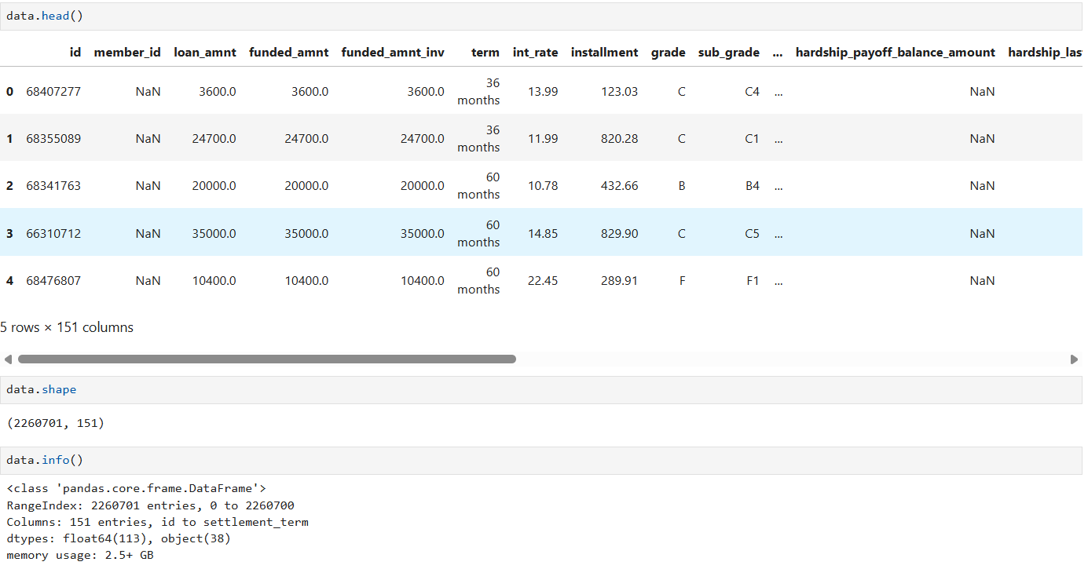
Missing Value Analysis
EDA revealed that many features had significant missing values, especially those related to post-loan performance.
Key observations:
- Over 60% of columns had excessive missing values
- Post-outcome variables posed a data leakage risk
- These columns were removed during preprocessing
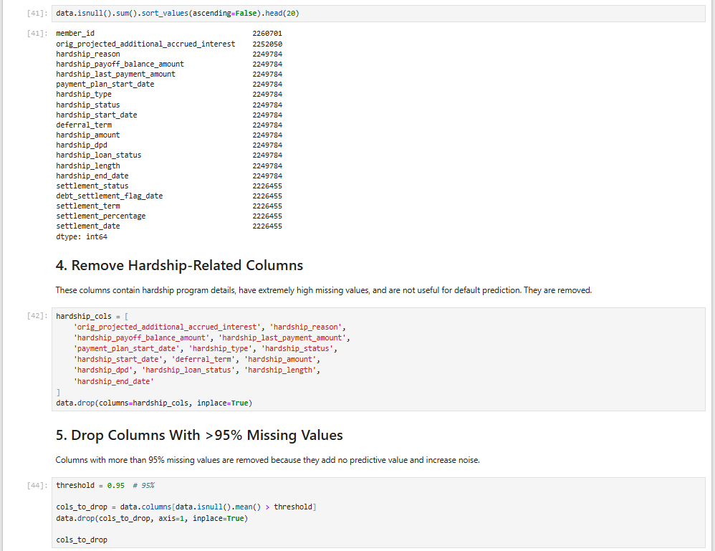

Target Variable Distribution (Class Imbalance)
The target variable (loan_status_clean) showed a highly imbalanced distribution, with non-default loans significantly outnumbering default loans.
Key insight:
- Class imbalance could bias the model toward majority class predictions
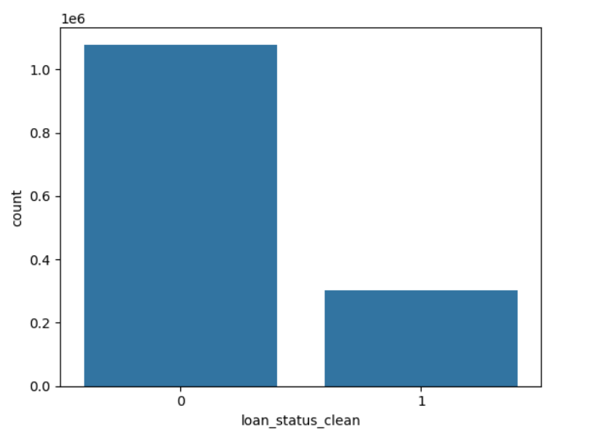
- This justified the use of SMOTE during model training

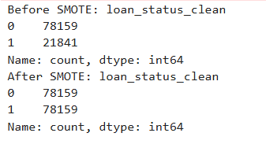

Numerical Feature Analysis
Key numerical features such as:
- loan_amnt
- annual_inc
- dti
- int_rate

were analysed using histograms and box plots.
Observations:
- Most numerical features were right-skewed
- Outliers were present in income-related variables
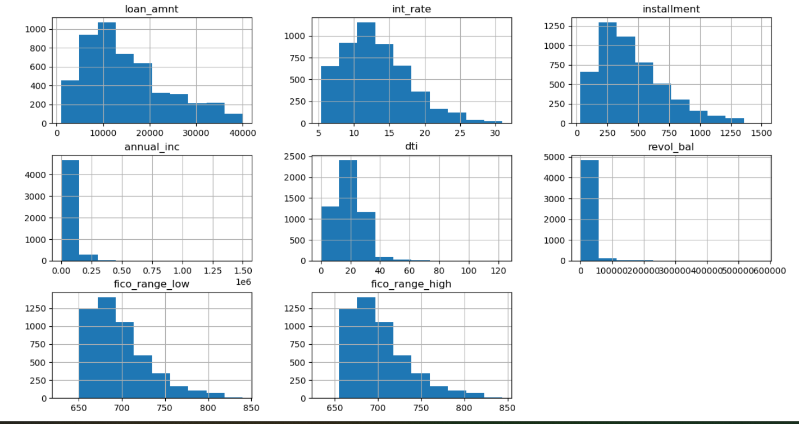
- Scaling was preferred over outlier removal

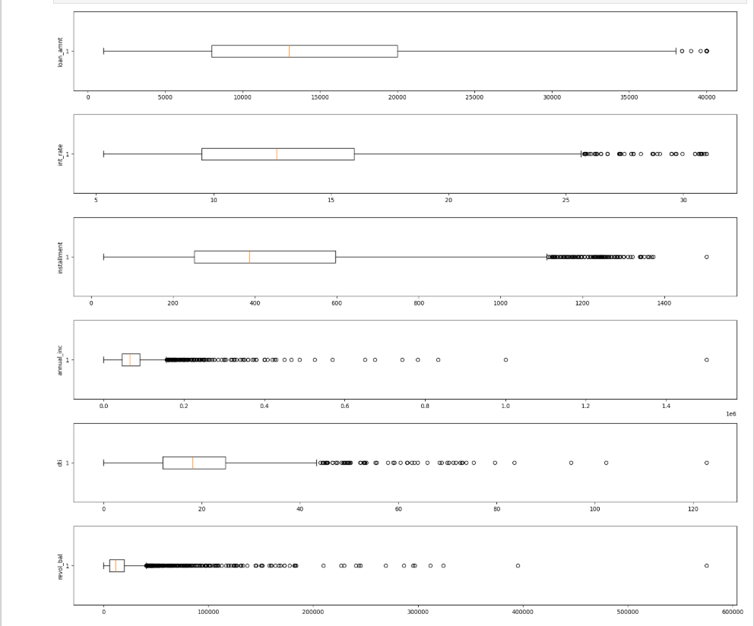
Categorical Feature Analysis
Categorical variables such as:
- grade
- sub_grade
- home_ownership
- verification_status
were analyzed using value counts and bar charts.
Observations:
- Loan grade showed strong separation between safe and risky loans
- Home ownership and employment length influenced default behavior
- Some categories were merged during preprocessing to reduce sparsity
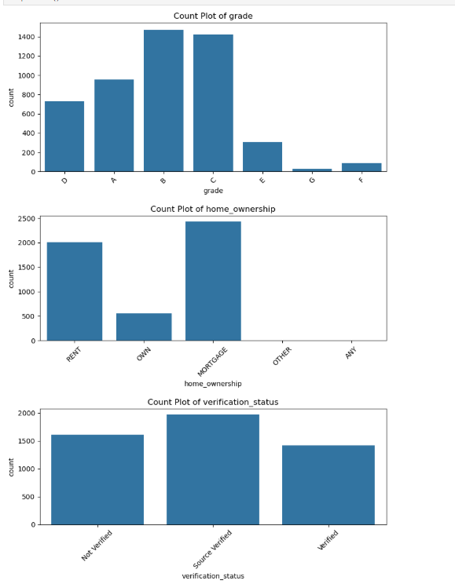

Correlation Analysis
A correlation matrix was generated for numerical variables to understand inter-feature relationships.
Key insights:
- Strong correlation between grade and int_rate
- Moderate correlation between credit score features and loan status
- Multicollinearity was handled during feature selection

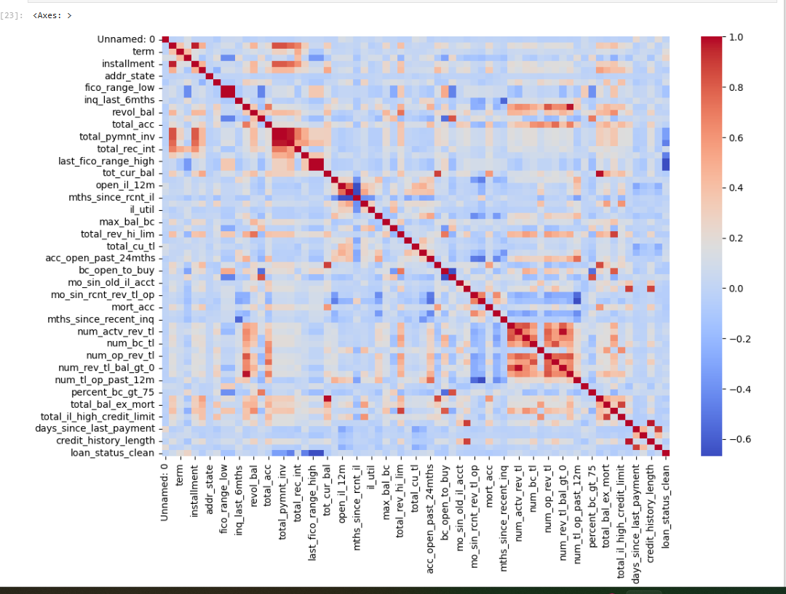
Automated Data Profiling Report
An automated profiling report was generated using Pandas Profiling (ydata-profiling), providing a comprehensive summary of:
- Feature distributions
- Missing values
- Correlations
- Warnings related to skewness and duplicates

This report complemented the manual EDA and ensured no critical issues were overlooked.

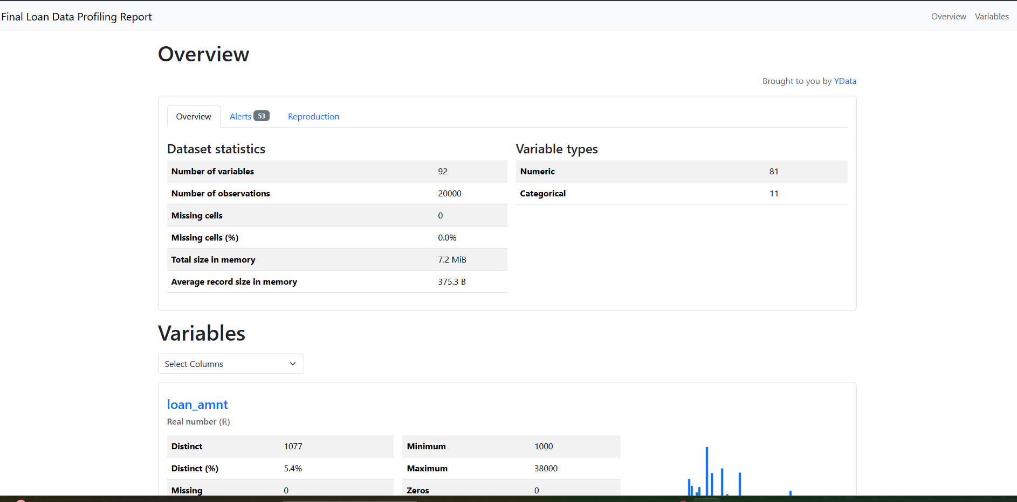

Summary of EDA & Profiling
The EDA and data profiling phase enabled:
- Identification of high-null and leakage-prone features
- Detection of severe class imbalance
- Insightful feature selection and engineering
- A strong foundation for preprocessing and modeling
A complete interactive profiling report is provided in the appendix.

Data Preprocessing
Data Cleaning
The raw Lending Club dataset contained a large number of irrelevant, highly sparse, and post-outcome variables that could introduce data leakage. To ensure model integrity, extensive data cleaning was performed. Columns with more than 60% missing values were removed, and all loans without a finalized outcome were excluded from the analysis.

Handling Missing Values
- Numerical features were imputed using median values to reduce the impact of outliers.
- Categorical variables were imputed using mode values.
- Features with excessive missingness and low predictive value were dropped entirely.

Target Variable Encoding
The multi-class loan_status variable was transformed into a binary target variable to enable supervised classification. Loans categorized as Charged Off, Default, and Late (31–120 days) were labelled as Risk (1), while Fully Paid loans were labelled as Safe (0). All non-finalized loan states were removed to prevent data leakage.

Categorical Encoding
- Nominal categorical variables were converted using One-Hot Encoding.
- Ordinal features such as loan grade were encoded to preserve their inherent order.
- Encoding was applied after data splitting to avoid information leakage.
Feature Scaling
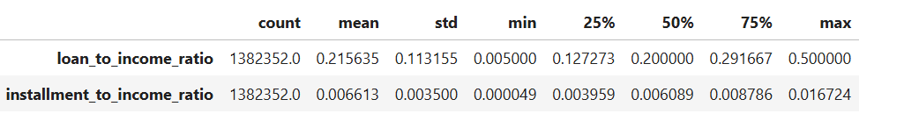
Numerical features were scaled using StandardScaler to normalize feature distributions. Scaling was applied only on the training data and then propagated to validation and test sets to maintain consistency.

Dimensionality Reduction using PCA
Principal Component Analysis (PCA) was applied to the standardized numerical features to reduce dimensionality while retaining 95% of the total variance. This step helped mitigate multicollinearity, improve computational efficiency, and stabilize downstream models.
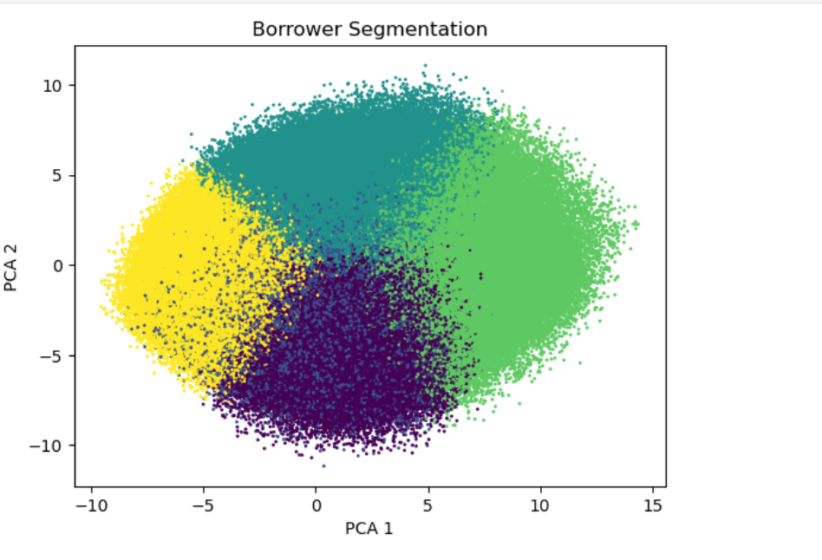

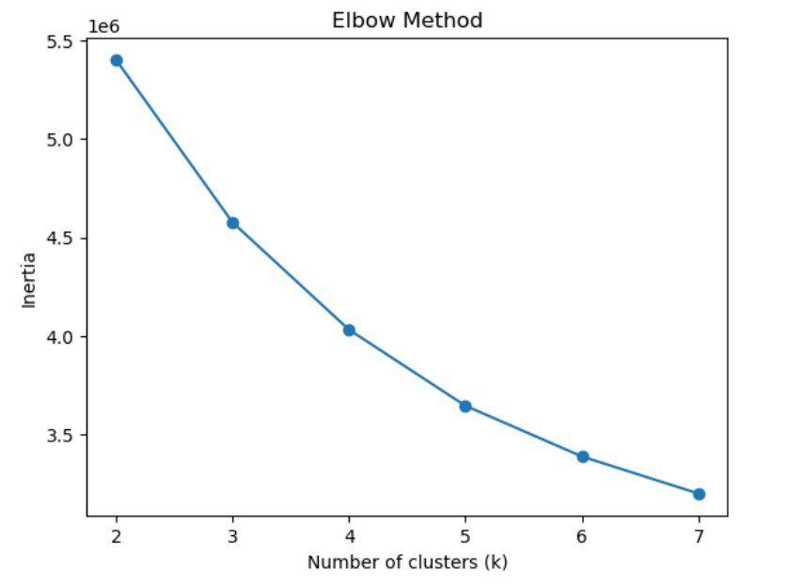
Borrower Segmentation using K-Means ClusteringK-Means clustering was applied on selected standardized financial and credit attributes to segment borrowers into homogeneous risk profiles. The resulting Cluster_ID was used as an additional engineered feature for supervised learning.
Train–Validation–Test Split
- Dataset split into 70% Training, 15% Validation, and 15% Testing.
- Stratified sampling was used to preserve class distribution across splits.
- The test set was held out completely until final model evaluation.

Class Imbalance Handling
The dataset exhibited significant class imbalance, with default cases representing a minority class. To address this, SMOTE (Synthetic Minority Over-sampling Technique) was applied only on the training set. This improved the model’s ability to learn patterns associated with rare default events while avoiding data leakage.

Model Building
To identify the most effective model for predicting loan default risk, multiple supervised machine learning algorithms were trained and evaluated. A diverse set of linear, probabilistic, instance-based, tree-based, and ensemble models was selected to ensure comprehensive benchmarking. All models were trained on the SMOTE-balanced training dataset to address class imbalance.

Logistic Regression (Baseline Model)
Logistic Regression was used as the baseline classification model due to its simplicity, interpretability, and strong performance in linearly separable problems. It estimates the probability of loan default using a logistic function and provides transparent coefficient-based insights into feature importance.
Naïve Bayes (Probabilistic Model)
The Naïve Bayes classifier was included as a probabilistic model that applies Bayes’ Theorem under the assumption of feature independence. Despite its simplicity, it serves as a useful benchmark and performs efficiently on large-scale datasets.

K-Nearest Neighbors (Lazy Learning)
K-Nearest Neighbors (K-NN) was implemented as a distance-based, instance-learning algorithm. The model classifies a borrower based on the majority class of its nearest neighbors in the feature space. Due to its sensitivity to feature scaling, standardized data was used.

Decision Tree Classifier
The Decision Tree classifier was used to model non-linear relationships between borrower attributes and loan default risk. It recursively splits the data based on feature thresholds, creating an interpretable rule-based structure.

Random Forest (Ensemble – Bagging)
Random Forest is an ensemble learning method that combines multiple decision trees trained on bootstrapped samples of the data. By aggregating predictions from multiple trees, it reduces overfitting and improves generalization performance.

Gradient Boosting Machine (Ensemble – Boosting)
Gradient Boosting Machine (GBM) was employed as a boosting-based ensemble technique that builds trees sequentially, with each model correcting the errors of the previous one. GBM is known for its high predictive accuracy in structured tabular data.

Model Evaluation
The performance of all trained models was evaluated using multiple classification metrics to ensure a fair and comprehensive comparison. Given the highly imbalanced nature of loan default data, emphasis was placed on recall, precision, F1-score, ROC-AUC, and confusion matrix analysis rather than accuracy alone.

Evaluation Metrics
The following metrics were used to evaluate model performance:
- Accuracy – Overall correctness of predictions.
- Precision – Proportion of correctly predicted defaulters among all predicted defaulters.
- Recall (Sensitivity) – Ability of the model to correctly identify actual loan defaulters.
- F1-Score – Harmonic mean of precision and recall.
- ROC-AUC – Measures the model’s ability to distinguish between default and non-default classes across different thresholds.

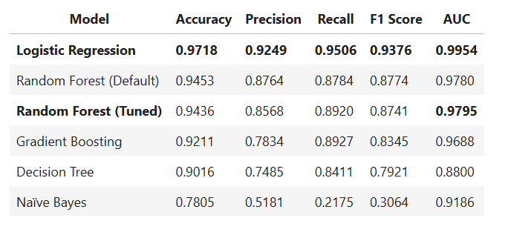
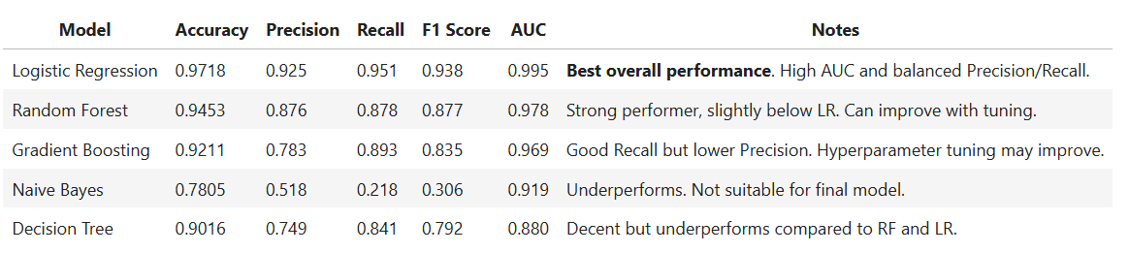
Model Performance Comparison

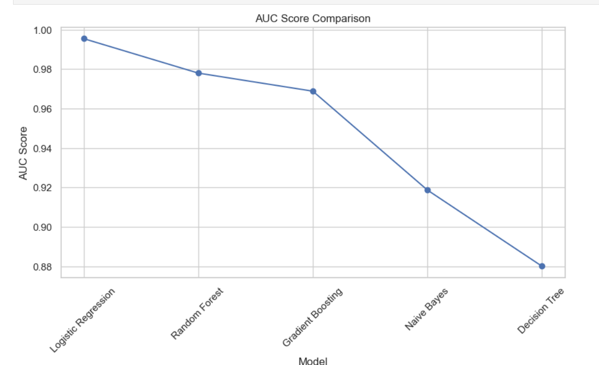
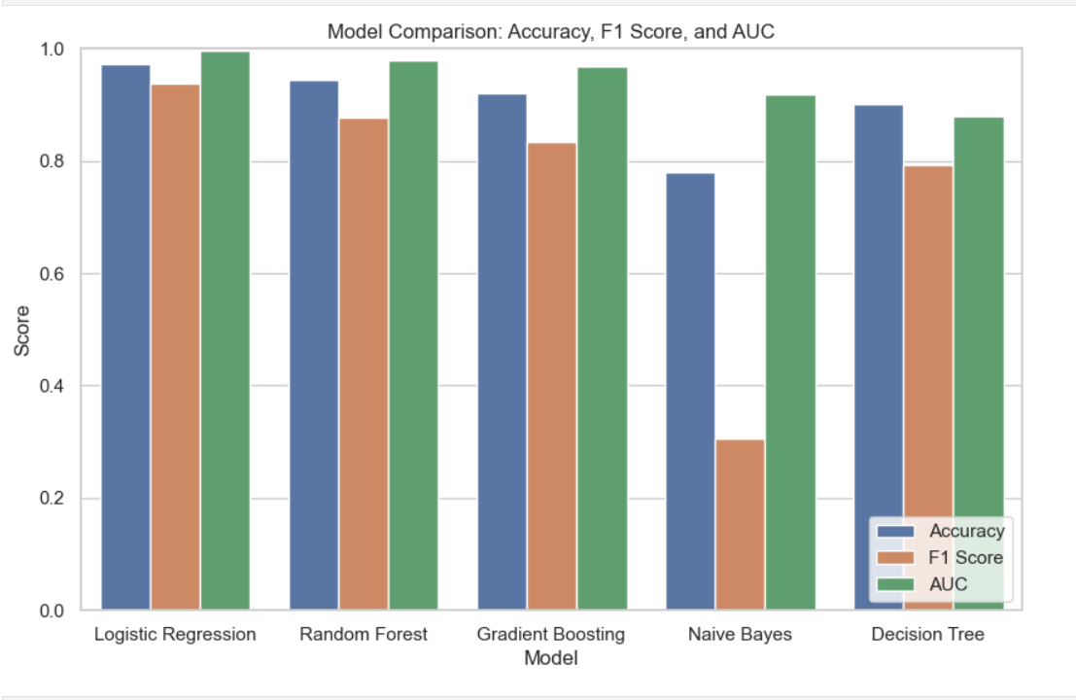

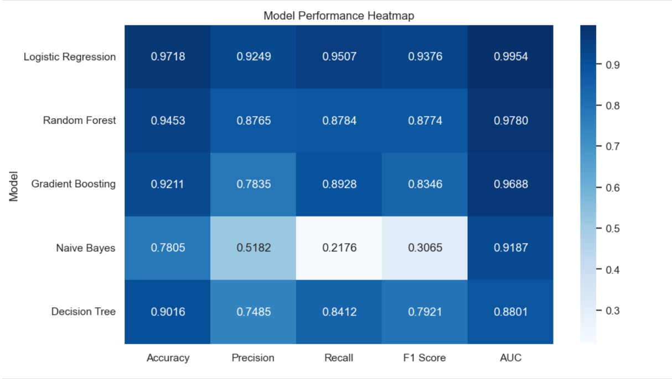
Confusion Matrix Analysis
Confusion matrices were used to analyze the classification behavior of each model in terms of true positives, false positives, true negatives, and false negatives. This analysis is particularly critical in loan default prediction, where false negatives (missed defaulters) can result in significant financial losses.
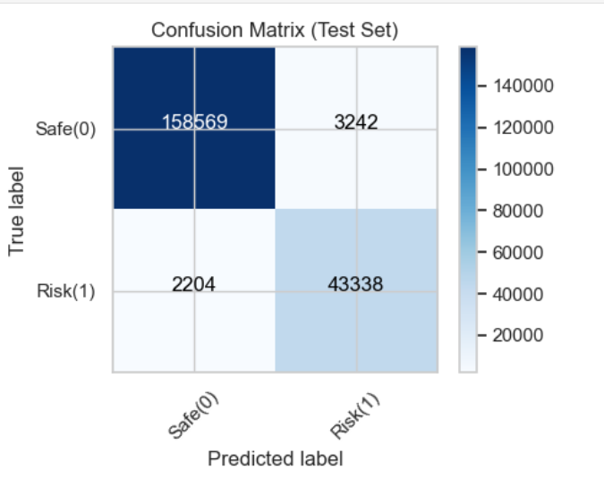

ROC Curve Analysis
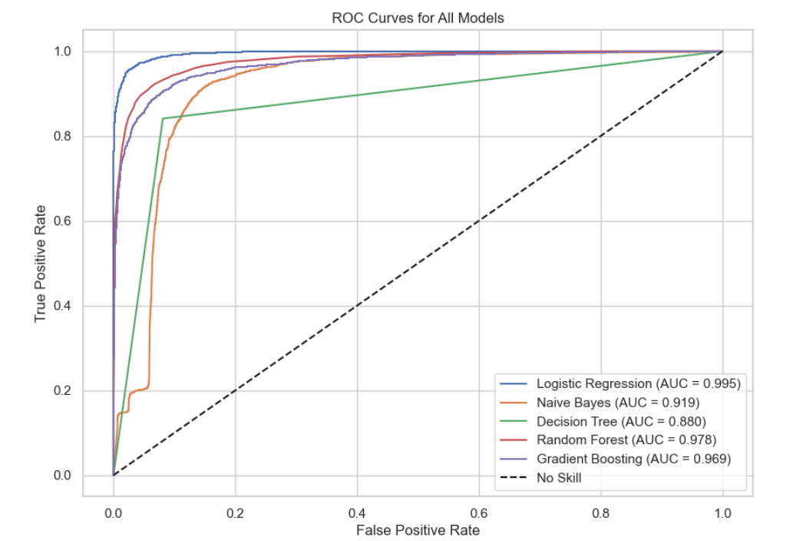
Receiver Operating Characteristic (ROC) curves were plotted to visualize the trade-off between true positive rate and false positive rate. The area under the ROC curve (AUC) serves as a robust indicator of model discrimination capability, independent of classification thresholds.

Final Model Selection
Based on the comparative evaluation across multiple metrics, the Logistic Regression model demonstrated superior performance, particularly in recall and ROC-AUC. Given the business objective of minimizing default risk, the model with the strongest ability to identify actual defaulters was selected as the final production model.

Final Model Selection & Justification
After evaluating multiple machine learning models using standardized performance metrics, Logistic Regression emerged as the best-performing model for this loan default prediction task. The selection was based not only on overall accuracy but primarily on ROC-AUC and recall, which are critical metrics in financial risk modeling.

Why Logistic Regression Was Selected
The Logistic Regression model achieved the highest ROC-AUC score of 0.995, indicating exceptional discriminatory power between default and non-default borrowers. Additionally, it delivered strong recall performance, ensuring that the majority of actual defaulters were correctly identified.

In comparison, ensemble models such as Random Forest showed slightly lower ROC-AUC values (~0.97–0.98) and did not provide a meaningful improvement after hyperparameter tuning. Given the marginal performance gap and increased complexity, Logistic Regression was determined to be the most efficient and effective solution.

Business & Practical Justification
From a business perspective, Logistic Regression offers significant advantages. The model is computationally efficient, highly stable, and inherently interpretable, which is a critical requirement in regulated financial environments. Its linear decision boundary allows stakeholders to clearly understand how individual features influence loan approval decisions.

Moreover, the model demonstrates robustness when combined with feature scaling and class balancing techniques such as SMOTE, making it suitable for real-world deployment scenarios.

Why Random Forest Was Not Selected
Although Random Forest is a powerful ensemble technique, it did not outperform Logistic Regression in this project. Despite hyperparameter tuning, the improvement in performance was marginal and did not justify the added model complexity. Furthermore, Random Forest models are less transparent, making regulatory compliance and business interpretation more challenging in financial risk applications.
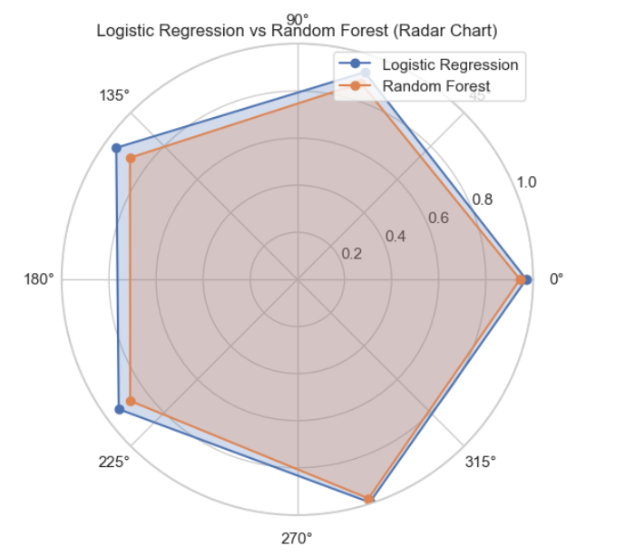

Final Model Summary
Criterion | Final Model
Model Selected | Logistic Regression
ROC-AUC | 0.995
Recall | High (Risk Focused)
Interpretability | Excellent
Deployment Readiness | High

The final model selection prioritizes business impact, model transparency, and risk mitigation over unnecessary algorithmic complexity.

Results & Discussion

Model Performance Results
The final Logistic Regression model demonstrated outstanding predictive performance on the completely unseen testing dataset. The model achieved a ROC-AUC score of 0.995, confirming its excellent ability to distinguish between high-risk and low-risk borrowers.

In addition to strong overall discrimination, the model achieved a high recall score, ensuring that the majority of actual loan defaulters were correctly identified. This is particularly critical in financial risk modeling, where failing to detect a defaulter can result in significant financial loss.

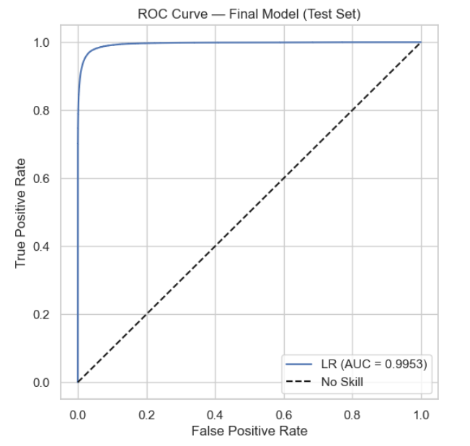
ROC Curve Image

Confusion Matrix Image

Interpretation of Results
The confusion matrix indicates that the model successfully minimizes false negatives, which aligns with the primary business objective of identifying high-risk borrowers. The high recall score reflects the model’s effectiveness in capturing actual defaults, even at the cost of a slightly higher false positive rate, which is acceptable in conservative lending strategies.

Feature Importance & Insights
Feature influence analysis revealed that variables related to borrower creditworthiness and debt burden played a dominant role in predicting loan default. Features such as debt-to-income ratio (DTI), credit history length, interest rate, and loan grade were consistently associated with higher default risk.

Engineered features, particularly Credit_History_Length_Years and borrower segmentation derived from K-Means clustering, contributed meaningful additional predictive power beyond raw input features.

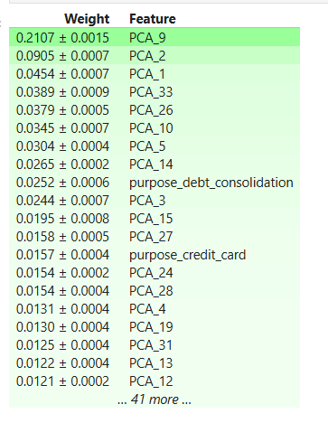

Business Impact Discussion
From a business perspective, the final model provides a reliable decision-support system for loan underwriting. By accurately identifying high-risk applicants, the model enables financial institutions to reduce default rates, optimize interest pricing, and improve overall portfolio health.

The interpretability of the Logistic Regression model further allows risk managers to justify lending decisions, ensuring compliance with regulatory and ethical standards.

Final Closing Line
Overall, the results demonstrate that a well-engineered, interpretable model can outperform more complex algorithms when combined with robust preprocessing and feature design.

Conclusion
This project successfully developed a high-performance loan default prediction system using real-world financial data from Lending Club. Through comprehensive data preprocessing, feature engineering, and rigorous model benchmarking, an optimal Logistic Regression model was identified.

The final model achieved an exceptional ROC-AUC score of 0.995 and demonstrated strong recall, ensuring accurate identification of high-risk borrowers. The integration of advanced techniques such as PCA and borrower segmentation through K-Means clustering further enhanced model robustness and interpretability.

Overall, this project highlights the importance of data quality, thoughtful feature engineering, and model interpretability in building reliable financial risk assessment systems. The resulting solution provides actionable insights that can support smarter lending decisions and reduce financial risk.

Future Scope
While the current system demonstrates strong predictive performance, several enhancements can be explored in future work. Deep learning models such as Artificial Neural Networks (ANNs) can be evaluated to capture more complex, non-linear patterns in borrower behavior.

The project can be extended into a real-time loan risk assessment system by integrating live applicant data through a web-based interface or REST API. Additionally, model performance can be further improved by incorporating alternative data sources such as transaction-level banking data or behavioral spending patterns.

Future work may also include advanced explainability techniques and bias detection frameworks to ensure fair and ethical lending decisions. Deploying the model using cloud-based platforms would allow scalability and integration into production-grade financial systems.

References
[1] Lending Club Loan Data, Kaggle Dataset.
https://www.kaggle.com/datasets/wordsforthewise/lending-club

[2] Scikit-learn Documentation – Machine Learning in Python.
https://scikit-learn.org/stable/

[3] Pandas Documentation – Data Analysis and Manipulation Tool.
https://pandas.pydata.org/docs/

[4] imbalanced-learn Documentation – Handling Class Imbalance.
https://imbalanced-learn.org/stable/

[5] Kuhn, M. & Johnson, K. (2013). Applied Predictive Modeling.
Springer.
[6] CampusX YouTube
https://www.youtube.com/playlist?list=PLKnIA16_Rmvbr7zKYQuBfsVkjoLcJgxHH

Appendix
Appendix A: Automated Data Profiling Report

An extensive automated data profiling report was generated using the Pandas Profiling library. The report includes detailed statistics on feature distributions, missing values, correlations, interactions, and potential data quality issues.

Due to its size and interactive nature, the complete profiling report is provided as a separate HTML file and is available in the project repository.

The profiling report can be accessed via the GitHub repository.

